Problem Statement: You work for XYZ Corporation. To maintain the security of the AWS account and the resources you have been asked to implement a solution that can help easily recognize and monitor the different users. Also, you will be monitoring the machines created by these users for any errors or misconfigurations. Tasks To Be Performed:

1. Create a dashboard which lets you check the CPU utilization and networking for a particular EC2 instance.

**EC2 instance created**

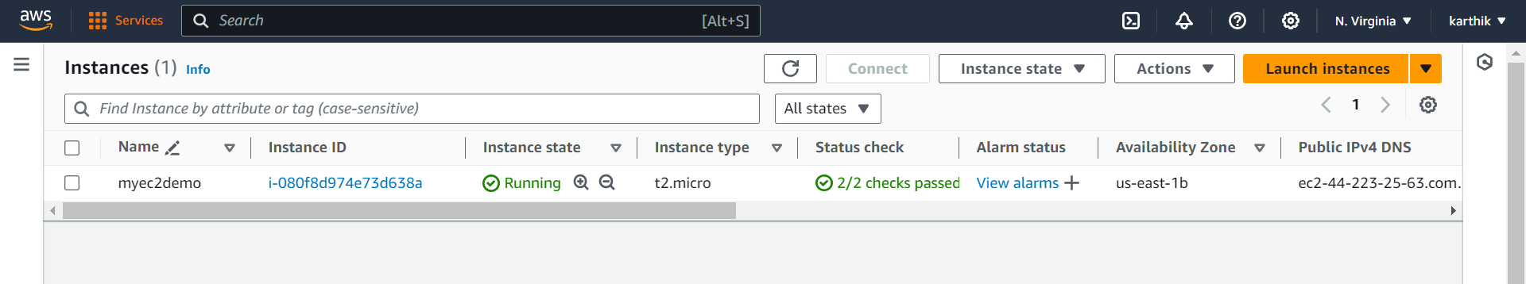

**CPU utilization and networking for a particular EC2 instance.**



